PCM – PIM – Product Information System& Master Data Setup for SKUs

Introduction

PCM – Product Catalogue Management system is a middle layer in the TUL Product Onboarding journey responsible for
- Generation of unique listing id or MP Code for PDP/PLP
- Generation of unique USSID or Unique Seller SKU ID for Price/Inventory/Seller or Rich Attributes
- Image or Video Link storage
- Duplicate Product Identification
- Product Taxonomy setup & maintenance
- Product Update Activities
- Master Data Setup or base system for shadow systems such as Data Lake

The onboarding journey for a new SKU begins from Seller Portal and ends in Commerce ( which decides the PDP/PLP/Search logic ) via PCM.

PCM system masters the product information, provides various workflows and quality check processes to ensure that the following objectives are achieved for the product data:
- Trusted
- Consistent
- Accurate
- Single version of data

Some of the key features of PCM application are listed below.
- Hierarchy Management

PCM maintains different hierarchies for e.g. Primary Hierarchy, Marketplace Sales Hierarchy, Luxury Sales Hierarchy, Indiluxe Sales Hierarchy, Brand Hierarchy etc. The product is associated with Sales & brand hierarchy based on the mapping maintained in PCM and exported to Commerce.

- De-Duplication :

PCM ensures that no duplicate product is created as multiple sellers upload data for the same product into the PCM system.
- First the GTIN number validation is done based on the GTIN type and checksum digit rule.
- Valid GTINs are checked against the existing products to avoid duplicate products getting created.
- The de-duplication rules are standardized across categories.

- Base –Variant relationship

Different variants (Color, Size, Volume etc.) of the same products are associated with base products in PCM and exported to Commerce. Commerce used this base-variant relationship to group all those variants on single PDP.
The criteria are defined per category based on which the variants are grouped. For e.g. for apparel products having same Brand, L4 code & Style code are linked to common base product.

- Rich attribute management

The rich attributes decide the order fulfillment behavior based on diff values (for. eg. COD, Gift Wrappable, Home Delivery etc.) and are maintained at USSID level & exported to commerce.
PCM maintains rich attribute default values at category(L4) and “Seller-category” level and the values are inherited to product during product onboarding process.
A utility has been provided to business users wherein they can
- Change the rich attribute default values at L4 / “Seller-L4” / “Seller-L4-Brand” level
- Change the rich attribute values at USSID & Listing id level
With Multiplatform changes live, rich attribute management is possible at platform level as well.

- Sell Now Channel

A separate “Sell Now” channel has been created for onboarding secondary p. A secondary seller does “Sell Now” for an existing product and that secondary USSID is associated with an existing listing ID. The product level information is commonly shared whereas the Seller level attributes (Seller Id, Name, End Date, Rich Attributes etc.) are maintained separately at USSID level.

- Image Processing

Product Images are very critical as they greatly influence the buying decision of a customer. Two important functionalities of image processing are Optimization & Re-sizing.
- First the product images are optimized using Kraken maintaining 85% quality
- Then DAM application resize them to different resolutions as per the requirements for different screens like PLP Image , PDP Main Image, Thumbnail image, Zoom image, Cart image etc.
- There are basic validation done to ensure the image quality and consistency for e.g. Image naming convention, Image aspect ratio, Image format.
- Image URLs are associated with the products and are exported to commerce.
- Functionality to add/delete Images has been provided to business user.
- All the image naming conventions, min/max images etc is standardized across categories.
- Luxury images differ in aspect ratio compared to Marketplace images but follow the same DAM process.
- Lead Variant: Seller is able to reuse the images for variants without having to upload images for every variant. For e.g. Size variants for a particular color variant can use same images. PCM associated same images to all the variants based on the lead variant logic.

- Brand Management

PCM is master system to maintain brand information.
- Brand LOV addition UI has been provided to user so that they can create Brands as per requirement.
- Brands can be classified as Marketplace/Luxury/Indiluxe.
- Products get classified in PCM as Marketplace/Luxury/Indiluxe based on the brand classification. The same classification is further used by commerce. This is removed with Multiplatform functionality.

- Product Enrichment

A utility has been provided to user to do bulk update of attributes for list of products.
- User does data extraction for list of products to be updated.
- A file is uploaded to SFTP, with the updated attribute details.
- The products are updated in PCM and exported to SP/Commerce.

- Product Deletion

A utility has been provided to business to delete product which are either rejected or stuck in PCM because of invalid data. Please note the products which are exported to commerce are not allowed to be deleted.

- Workflows

PCM system provides various workflows and quality check processes to ensure the good data quality for product information
- Seller Type is defined in Seller Portal at the time of Seller Onboarding i.e. Platinum, Gold etc
- Product uploaded by Platinum Seller are approved automatically and exported to workflow.
- Non-Platinum seller products enter into a QC workflow and need to be approved manually from PCM product cockpit

** Currently all the sellers are created as platinum seller and all workflows have been removed.

Pre-requisites for Product Onboarding
- Seller should be registered in the Seller Portal
- Seller should be legally onboarded for a platform – MPL, LUX, Beauty
- Seller should have legally onboarded categories for the respective platform
- Seller should have updated the commissions for the respective categories in order to allow them to reflect in the New Product Upload GUI
- Seller should have decided the SKU codes for his respective SKUs and should have uploaded the images, following the naming conventions, via SFTP to the system atleast 2 hours before starting the Product onboarding journey

Scope of the Document
The following document will cover PCM capabilities to address new Platform addition/Line of Business Addition and the Product Onboarding Journey for the same following the functionalities of the PCM system.

• Product Onboarding – Journey (SP-PCM-Commerce)
- Primary/Secondary Seller
- Initial Folder based / Recent Kafka
- Jewellery product onboarding weight variation
• Architecture
- De-Duplication/ Variant De-duplication
- Base Variant / Lead Variant
- Primary Hierarchy and Sales Hierarchy
- Master Data Dictionary – Classification/Category attributes
- Core MDD
- DAM – Digital Asset Management

• Multi-platform (Same Product listing on multiple platform) or addition of new line of Business
- Add Platform
- Add Category to the Platform
  - Primary Hierarchy
  - Sales Hierarchy
  - Mapping between Primary and secondary hierarchy
- Addition of attributes to the categories – MDD File
- Defining validation rules for categories – MDD File

Other Features in PCM
- Rich attribute Functionality
- Bulk Update/Data Extract functionality
- Seller Details Update
- Product Delete
- LOV UI/Bulk
- Brand UI/Bulk

Architecture of PCM
- De-Duplication/ Variant De-duplication
- Base Variant / Lead Variant
- Primary Hierarchy and Sales Hierarchy
- Master Data Dictionary – Classification/Category attributes
- Core MDD
- DAM – Digital Asset Management

De-Duplication/ Variant De-duplication

Previously, when two products with different EANs were uploaded with same Size, Colour, Style Code, Brand code and L4 category, the product were getting listed, considering the EANs are for 2 different products. This resulted in duplicate listing. To resolve this problem, the De-duplication module was developed.

﻿Requirements
Key requirements for catalogue structure are as follows:
- A Seller will publish the product information for every USSID product.
- PCM system should identify the duplicate products and ensure that only one version of that product is created in PCM.
- Duplicate products will be identified based on certain de-duplication attributes which will vary from category to category.

﻿De-Duplication Process Explained
Design Approach/Considerations
TUL has designed the de-duplication workflow considering the following parameters:
- Source catalogue should contain the duplicate products based on different seller’s USSID.
- Master Stage catalogue should contain the single version of the product getting deduplicated based on the category specific matching attributes.
- Category Managers should have the provision to review the de-duplication matches if they need to act on it.

De-Duplication Workflow
Following figure depicts the end-to-end flow for de-duplication process in PCM:
Figure 1 De-duplication Process Flow
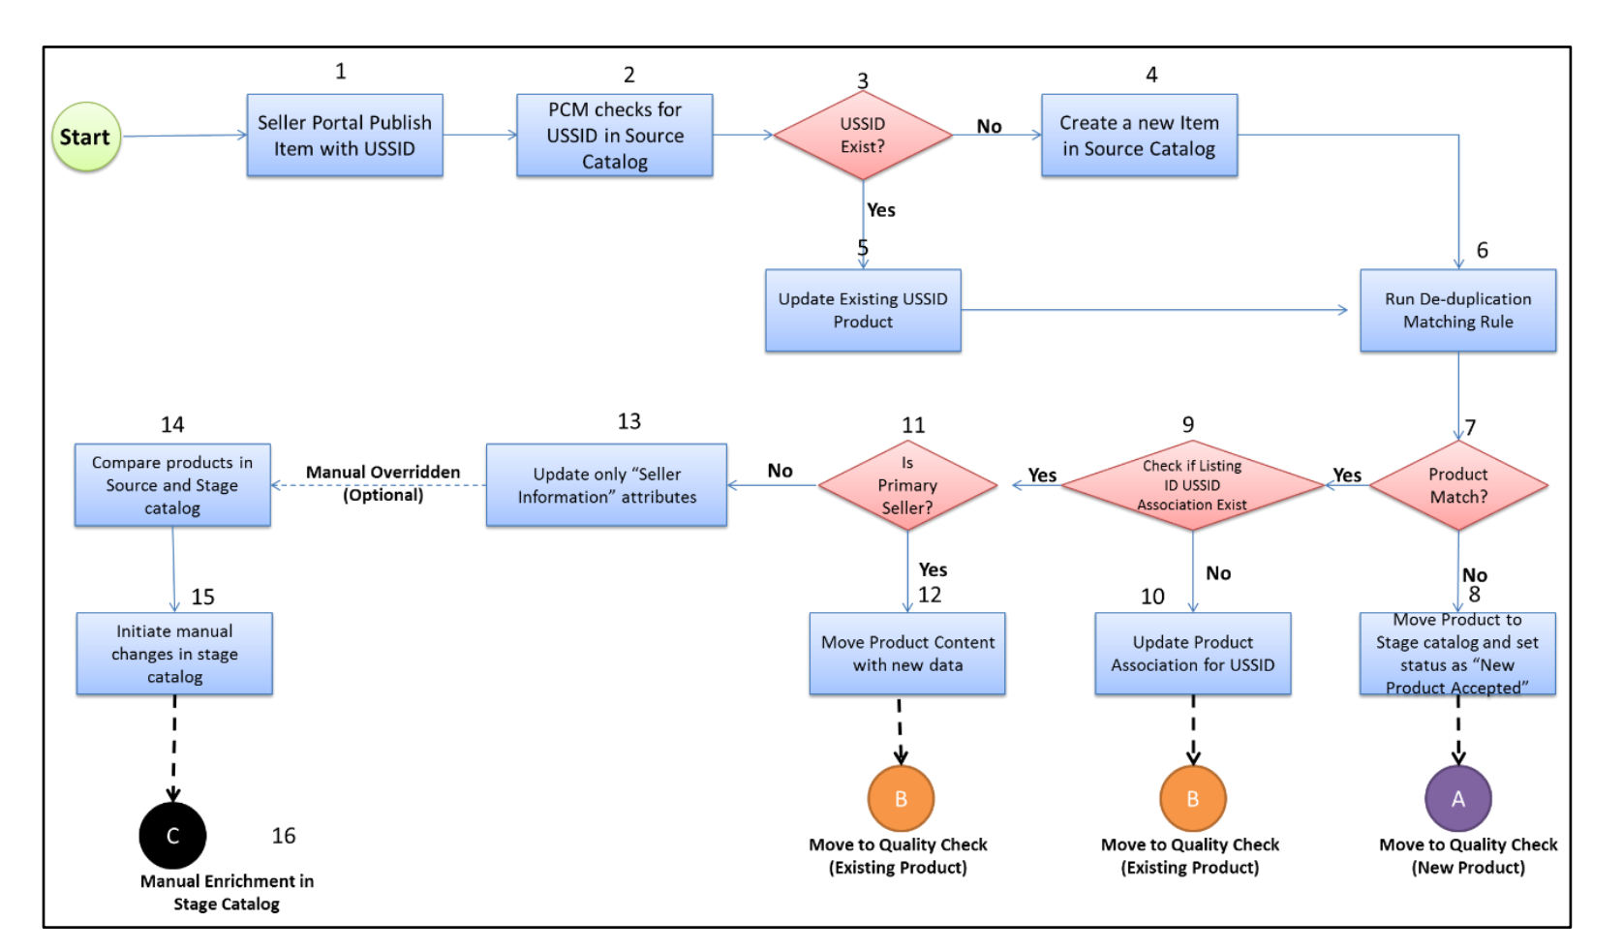

The previously mentioned flow chart is based on the following sequence:
1. Seller portal publishes the product with USSID information and other product content into
PCM.
2. PCM looks for the USSID in the source catalogue.
3. PCM checks if the incoming USSID already exists in the source catalogue.
4. If USSID does not exist, PCM will create a new item inside the source catalogue with
USSID as the primary key.
5. If USSID exists already, PCM will update the product with the incoming information.Tata
6. PCM system runs the de-duplication rule as specified in the section “De-Duplication”
rules.
7. PCM system checks if any product matches the duplicate rules in the online catalogue.
8. If no product match is found, it will move the item to Stage catalogue with product status
as ‘New Product Accepted’ and initiate quality check process for the new product
thereafter.
9. PCM system checks whether the Listing ID USSID association exists for this request.
10. If association does not exist, PCM system moves the product to Stage catalogue with
product status as ‘Existing Product Accepted’ and initiate quality check process for
existing product thereafter. This step would associate the USSID with the existing Listing
ID.
11. If association exists, PCM system checks whether the incoming request seller is a primary
seller.
12. If seller is a Primary seller PCM system moves the product to Stage catalogue with
product status as “Existing Product Accepted” and initiates quality check process for
existing product thereafter. As this is considered as a case of product update from the
primary seller, it will update the product content as well.
13. If request is not from the primary seller, PCM system will update the “Seller Information”
attributes for this USSID. This request could be a potential request for updating rich
attributes as well; hence de-duplication will not flag this as duplicate.
14. Additionally, as a manual overridden process, category team can compare the seller
provided, product content to the listed product in an online catalogue using out of the box
Hybris PCM comparison utility.
15. Once category managers observe any better content from the secondary seller, they will
manually initiate the changes in the stage catalogue and the PCM will follow the manual
stage catalogue process henceforth.

Base and Variant

In order to show the different size or color variants of the same product, a grouping mechanism was imperative. Based on this requirement, the base and child variant approach was designed.

﻿Design Approach
PCM maintains the base and variant product information as parent child relationship and the same gets reflected in eCommerce while displaying the product in PDP. Every product which is required to have a common base product contains attribute(s) which uniquely identifies the base product. PCM system identifies those unique attributes and manages the base and product relationship. These attributes will vary from product category to category, that is, apparel may have different attributes than footwear.

﻿Base and Variant Definition
This is considered to be the parent or core product which is defined by the manufacturer or the brand. This product contains the common product definition. For example, Brand X Formal Shirt Summer Special will be a base product. However, the different sizes and colours available for the products are considered as Variant Product. These products will be distinguished based on the variant attributes and it varies from category to category. Details of variant attributes per category are explained in subsequent sections.

﻿Base and Variant Attributes
This section outlines the attributes which are used to maintain base and variant products.
Base Attributes – These are the attributes which are common across all variant products across all the sellers. The PCM system creates the base and variant product relationships for all these variants having the same values.
Variant Attributes – These are the attributes which vary at the variant level and determine what distinguishes a variant from base product.
Example of use of base and variant logic in Apparels category
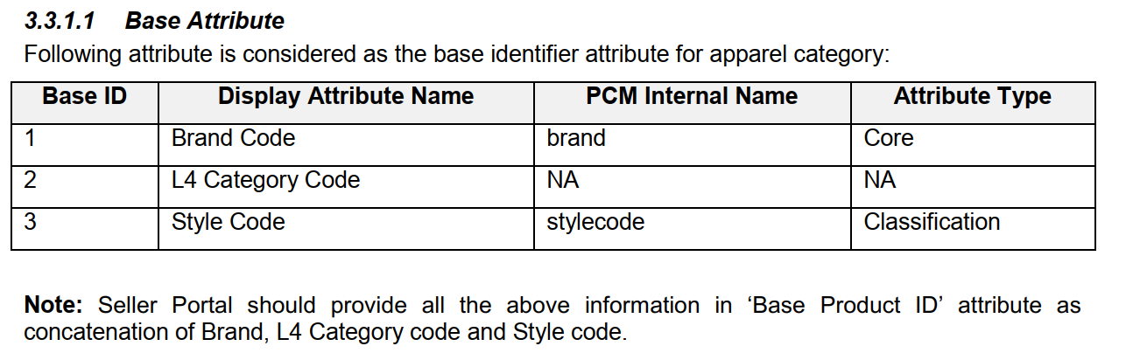

Primary Hierarchy and Sales Hierarchy

For the purpose of listing and showcasing a product, a product hierarchy is required. In the world of cataloguing, it is termed as Product Taxonomy. In TUL, product taxonomy is of dual nature, viz- Primary Hierarchy and Sales Hierarchy.

While listing the product, product taxonomy is required. For the same purpose, primary hierarchy is required. The primary hierarchy is the main category where the product will be listed. It is termed as Master Primary Hierarchy and Annotated by MPH code.

MPH hierarchy is responsible for the entire categorization of products at the backend, and the SKU lifecycle is dependent on the same.
However, for displaying the products on the front end, high amount of flexibility is required, as products may be clustered or grouped. For the same purpose, Sales hierarchy is created.

Sales hierarchy of the products are unique to each platform and cannot be cross used in interdependent platforms. Sales hierarchies are categorized as follows
  - MSH – Marketplace Sales Hierarchy
  - LSH – Luxury Sales Hierarchy
  - ISH – Indiluxe Sales Hierarchy
  - YSH – Beauty Sales Hierarchy

For proper functioning of the front-end, index, and Product Link Page in front end, the MPH hierarchy is required to be mapped to one or more sales hierarchies. This is a one-time configuration done at the beginning of product-sales hierarchy mapping. Based on the same, particular primary category products get linked to multiple sales hierarchies and accordingly become visible on particular platform,PLP, and Search.

Business rules with Master Data Dictionary, attributes and Validations

Each category has its own set of attributes, of which some are common to all categories, and some are common to specific group of sub-categories. In order to have a planner’s view on the same, the Master Data Dictionary concept was created.
Master Data Dictionary or MDD for a particular category will have
- The hierarchy – MPH hierarchy with names, but no codes
- The Attributes for the category
- The Attribute types, length, validation rules – LOV,Int, String based
- Attribute category – searchable, PDP display, Indexable, Multivalued, Mandatory,
- Attribute to Category mapping- which sub-categories will have which L4s

Attributes are themselves divided into 3 types,
- Core Attributes – The standard set of mandatory attributes which are common and required for product listing across all categories
- Classification Attributes – set of attributes relevant and unique to each Level 1 category of Line of Business, which are used for display, search, and reporting purposes
- Seller Rich attributes – Unique attributes associated with sellers against the SKU codes, which help in defining key PDP, Non-PDP, promotions, marketing and logistics details such as seller modes, packaging info, delivery fulfilment mode

Following rules are applicable to setup attributes, validations, and master data dictionary.

﻿The Rule Types are as follows:
- Attribute Business Rule: Describe the operations, definitions and constraints that are applicable.
- Standardization: To implement technical & business standards (e.g. description in Upper Case).
- Validation: To validate or confirm the authentication to be performed by the system (e.g., EAN)
These rules are in respect to the business perspective, so that other IT/business rules, mandatory /optional, attribute length, LOV and so on, will be captured in MDD document.

﻿Generic Rules
Attribute Length Rule
Rules related to the length of the attributes are documented in Master Data Dictionary and will be configured using out of the box Hybris Configuration.
For example, Style Note should not be more than 220.
Attribute Mandatory Rule
Rules related to the nature of the attributes, mandatory or optional are documented in Master Data Dictionary and will be configured using Out of the box Hybris Configuration.
For example, Style Note and Colour Family are mandatory attributes.
Additional Attribute Mandatory Rule
This section will outline the rules where mandatory or optional property cannot be set at attribute level and would require PCM system to write additional codes.
Multipack Based Mandatory Check
Description: If Multipack is “Yes” then Pack Quantity and Pack Colour attributes are mandatory
Validation Rule: Attributes Involved
PCM Attribute Display Name | PCM Attribute Internal Name
Multi Pack | Multipack
Pack Quantity | Pack Quantity
Pack Colour | Pack Color

Condition 1
Multi Pack = Yes
Validation
Pack Quantity and Pack Colour should be mandatory
Condition 2
Multi Pack = No
Validation
Pack Quantity and Pack Colour can be optional

﻿Images Mandatory Rule
PCM system will check for the mandatory images, and it will be based on the image type and will vary from category to category

DAM – Digital Asset Management

Digital Asset Management is a function use to resize uploaded images, store them in different formats, and pass the same to PCM for product listing. DAM uses ImageMagisk for image resizing purpose, and the entire process of resizing to storage is automated.

    - PCM system will make a call to DAM system providing the USSID or media file name and DAM will send the response back with the URL. This end-to-end design is outlined in DAM design document.
    - DAM will create the following four types of the images for the incoming product images and same will be responded back to PCM:
      - Cart Image
      - Search Page Image
      - PDP Image
      - Zoom Image

6 resolution for MP:
437Wx649H
1348Wx2000H
252Wx374H
97Wx144H
113Wx168H
450Wx545H

6 resolution for LUX:
97Wx108H
658Wx734H
58Wx65H
1316Wx1468H
320Wx357H
432Wx482H
Upload image resolution:
MP: 1348Wx2000H
LUX: 1316Wx1468H
Aspect Ratio:
MP: 1.33
LUX: 1.11

If the images are not in the specified format for the respective platforms, then the Images will be rejected, and the product will not be onboarded.
Similarly, for videos, not direct video uploads are allowed; only youtube links for the videos are to be added to the CSV file in the designated video url attribute during product onboarding. If not added, the link can be added later via SKU Edit & Retrigger.

Other Features in PCM

Rich attribute Functionality
Rich Attribute functionality is used to update any rich attributes in bulk. The upload csv is prepared with ussid, rich attribute name and rich attribute values against the corresponding USSIDS

Bulk Update/Data Extract functionality
Data Extract Functionality
This functionality allows business user to get the CSV dump of details against the USSID or listing ids on specifying any of the following input
- Ussid Level Data extract
- Listing Id level Data extract
- LOV Data extract
- L4 category level Data extract with filters
- L4 Category level Data extract without filters.

Bulk Update Functionality
- Similar to the bulk download functionality, bulk update functionality works by enabling addition of attributes against listing id and attribute name.
- With the bulk update functionality, Users can upload classification attribute values against a given classification attribute.
- Along with images, users can also create, update, or delete images with bulk update functionality

Seller Details Update
Users can update seller name or details using the seller details update CSV, similar to bulk update functionality

Product Delete
Product Delete function is restricted to support team, and allows deletion of
      - Rejected Products from PCM
      - Business initiated product deletion of USSID or listing id

LOV UI/Bulk
For validation purposes, List of Values or LOV is a data type created. For instance, gender will only have men & women as LOV, and any value apart from these 2 values will throw an error. In order to add a new LOV child or Unisex, the LOV addition UI which is a limited user interface of Hybris HMC is used. LOV values can be added via Screen {single} or in Bulk via the CSV mechanism.

Brand UI/Bulk
For addition of brand or brand description, this utility is used. The Brand addition UI which is a limited user interface of Hybris HMC is used to create or update Brand code, brand name, and description via UI, or the bulk update utility of using CSV is used to update Brand names or descriptions.

Please note, for the other functionalities to work, SFTP access to a repository is required, where business users transfer files, and the utility consumes the same.

.

New Product Upload Journey

New Product upload
- New products can be uploaded using the new product upload feature.
- It will be available under product listing in home page.
- Under product listing we have option “Product bulk download/Upload sheet” and “Product bulk download/Upload priority sheet” on click of these options the new product adding journey will start.
- Need to select the Categories and click on “Download format” to download the excel sheet.
- Product images should also be uploaded filezila.
- Once the excel sheet is downloaded, we need to enter the all the Mandatory fields of the product like HSN code, Seller SKU, Product Title etc
- There will be a filed to enter ‘Platform Name’ for the products.
- All mandatory fields should be filled in the excel sheet.
- Once all the necessary fields are filled, we need to save the file in CSV format, and upload the file.
- Once the file to uploaded to the server, it will show the status of the file whether upload is success or failed.
- If the upload of the file is failed, then specific reason will be displayed in the sheet.
- Common reasons for failed cases are Maximum character length exceeds, not filling of mandatory fields etc.
- Once the file get uploaded, then the particular products will be sent for approval, once the products get approved those will get listed.
- The clone job takes minimum of 4-5 hours to get approved.

Image formats supported
6 resolution for MP:
437Wx649H
1348Wx2000H
252Wx374H
97Wx144H
113Wx168H
450Wx545H

6 resolution for LUX:
97Wx108H
658Wx734H
58Wx65H
1316Wx1468H
320Wx357H
432Wx482H
Upload image resolution:
MP: 500W*666H
LUX: 1316Wx1468H
Aspect Ratio:
MP: 1.33
LUX: 1.11

Step 1:
Home Page for seller portal: new product can be uploaded by clicking on product listing
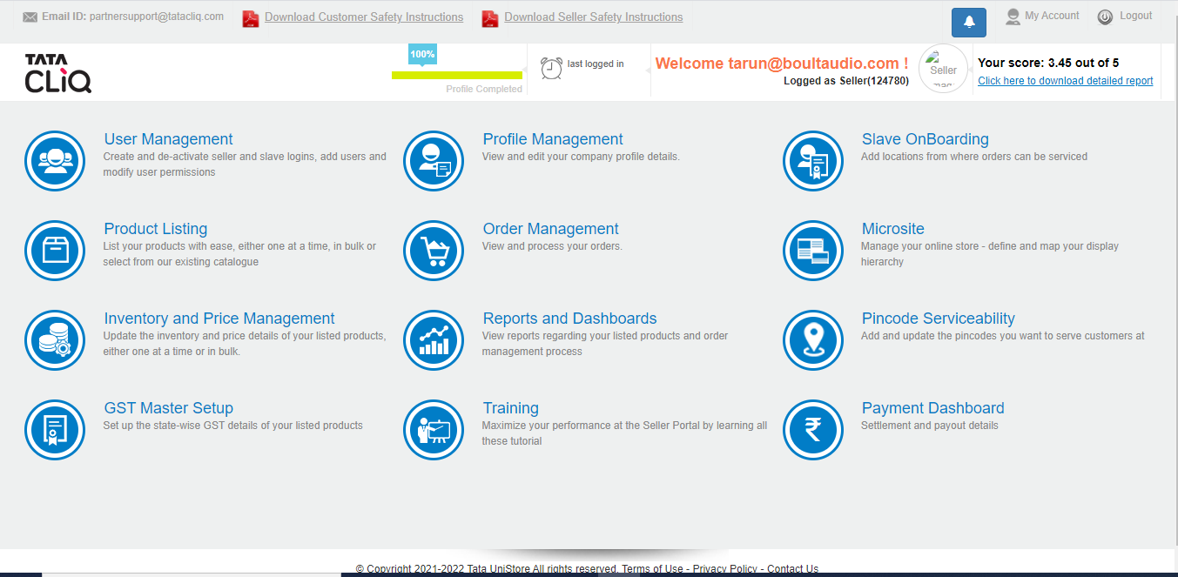
Step 2: Upload Sheet can be found under Product listing- User needs to select the categories for the product to be uploaded.
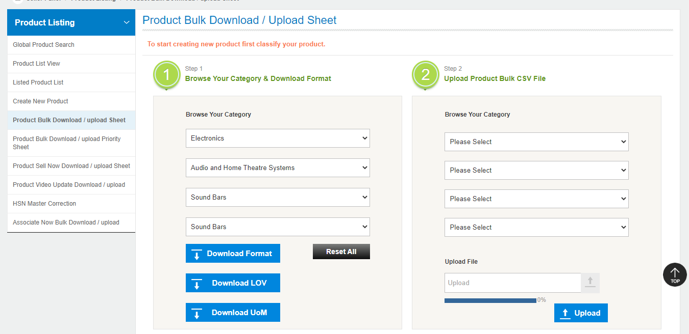

Step 3: Once the Categories are selected then click on Download format to download the excel sheet.
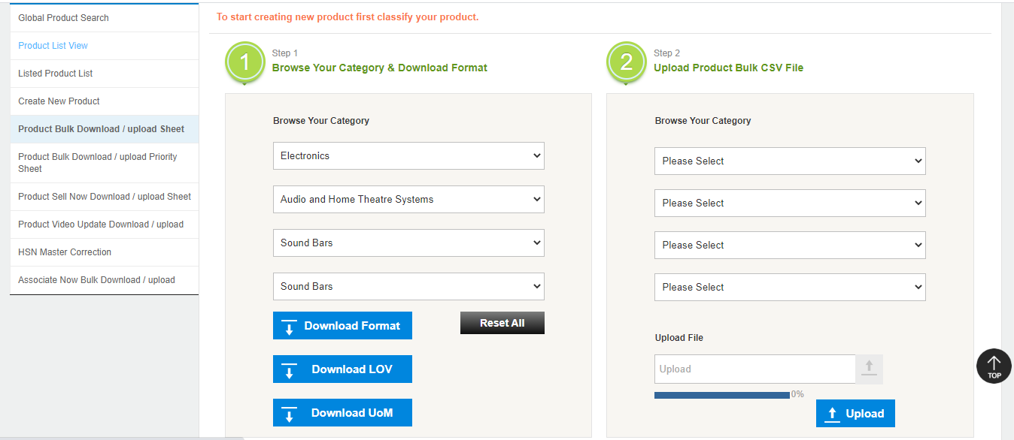

Step 4: Enter the All the Mandatory fields in the excel sheet.
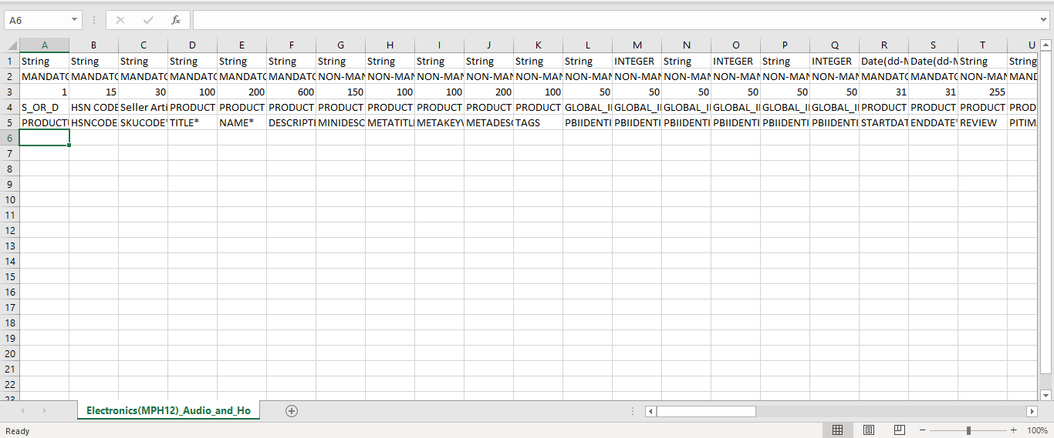

Step 5: Once all the details are entered, then save the file in CSV format and upload.
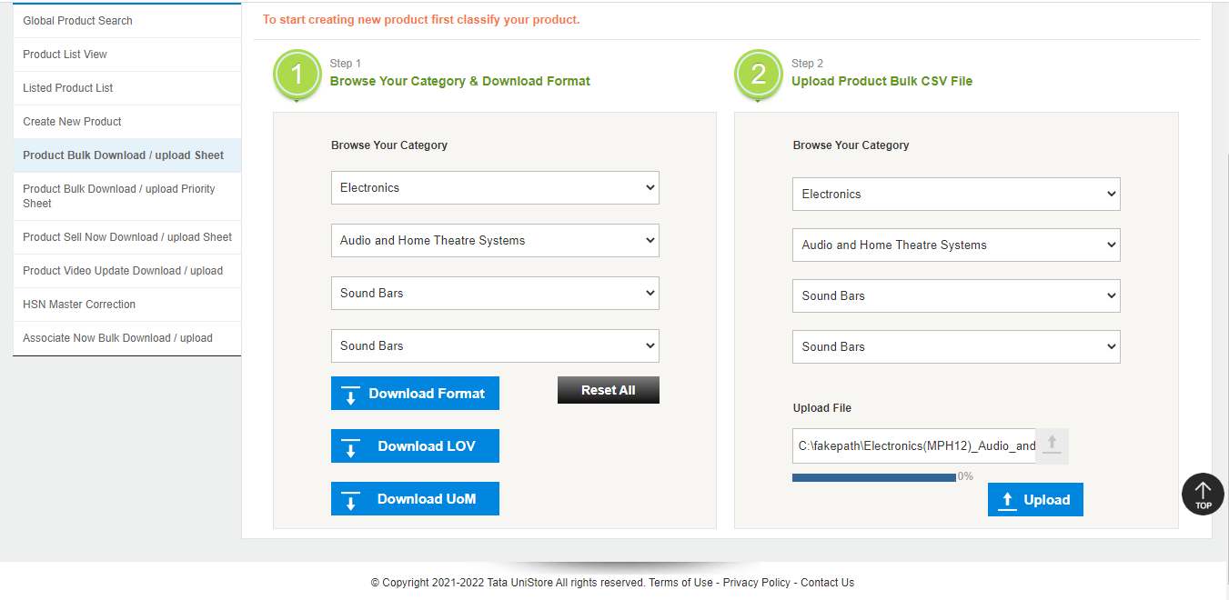

Step 6: Once the file is uploaded, then it will be sent to pending for approval and then finally the product will be listed.
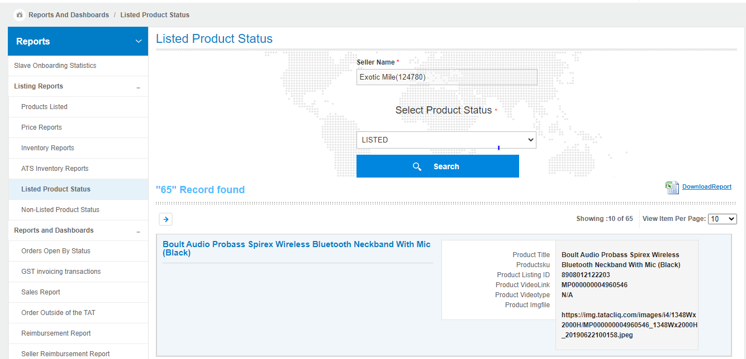

Sell Now or Multi-mapping
If the products are already listed, then the sellers can opt for duplicating the product details by keeping the same listing id, but by creating a unique USSID against their seller code. This is called Sell Now.
Sell Now saves the cost of cataloguing by allowing the use of existing listing id. The process of Sell now does not require fresh images, and allow efficient utilization of already created listings.

The listing id is created by product upload of first seller, termed as Primary Seller, and the ussid used to create the listing for the first time is called as Lead Variant ID. All images are uploaded at Lead variant id, and update of images carried at lead variant id level.

The next seller who does sell now for the existing listing is termed as Secondary Seller. The process of Sell Now is defined as follows.

Guidelines for Multi-Mapping (Sell Now)

- Please Login Using Seller Credentials:
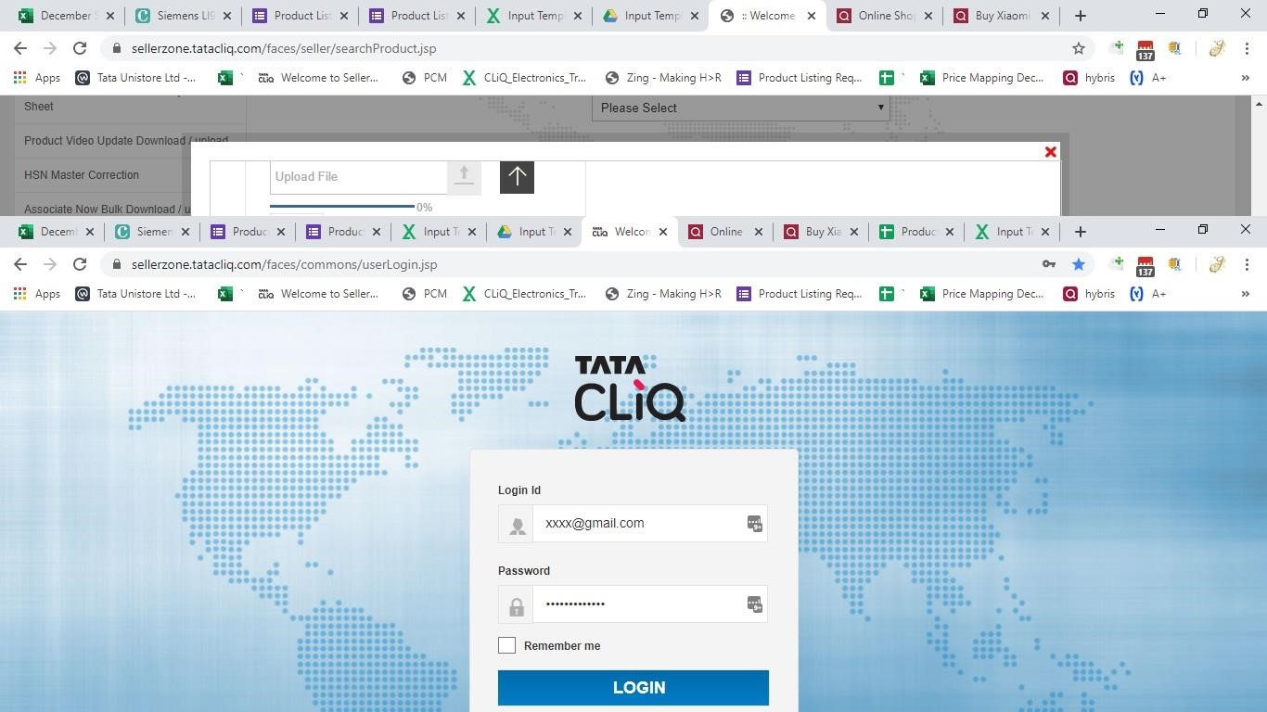

- Select "Product Listing" option from Seller Panel:
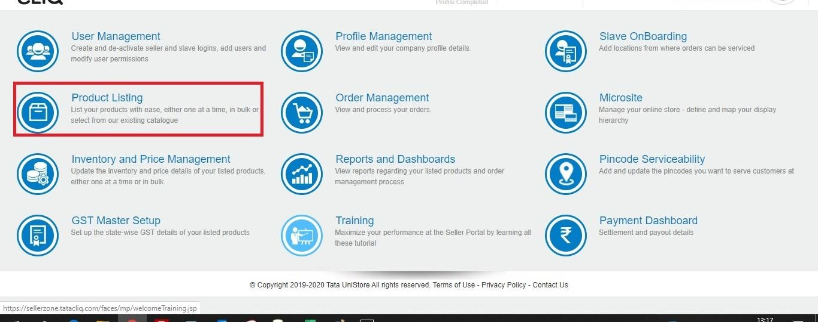

- Select "Global Product Search" option on the left navigation:
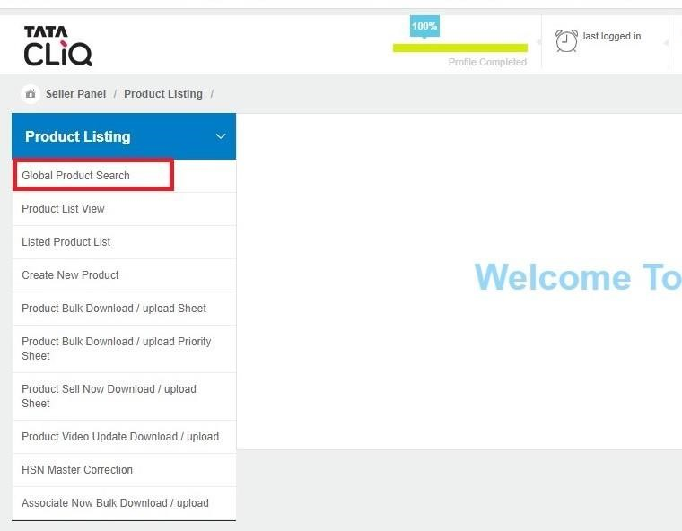

- Paste the Listing ID that is to be mapped and press the “Search” button. (Do not press enter button after pasting Listing ID, Use search button only):
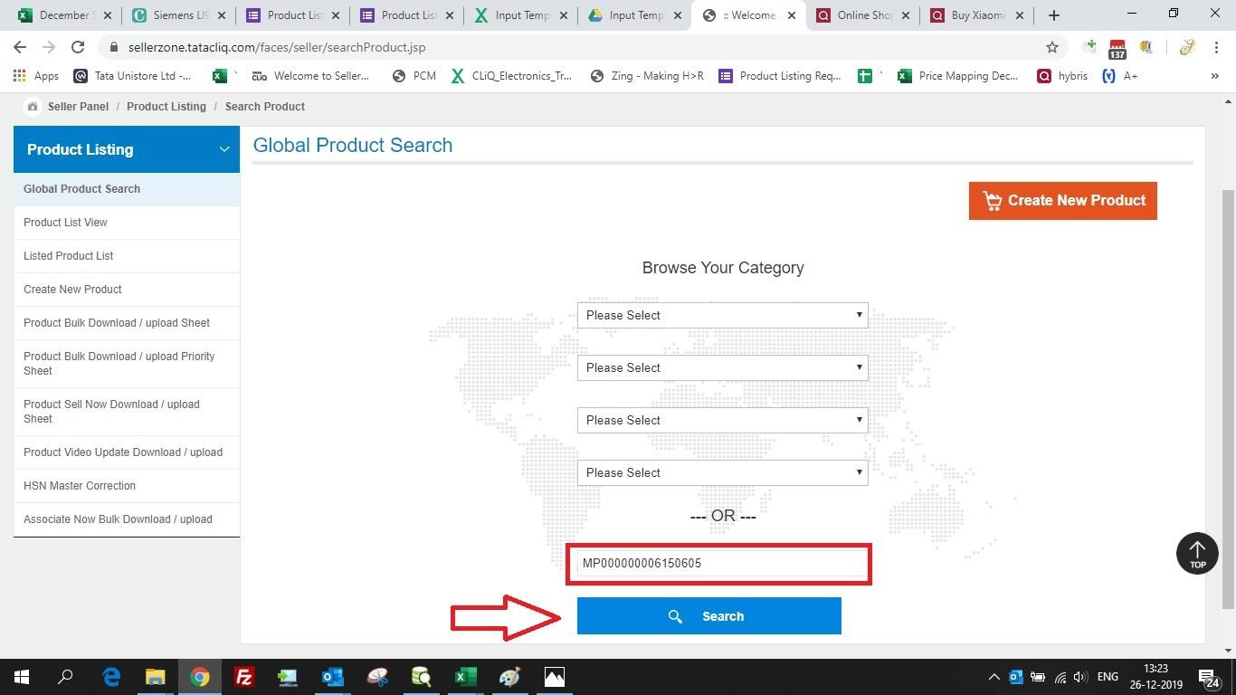

- Once result for Listing ID appears, click on the icon with shopping cart.
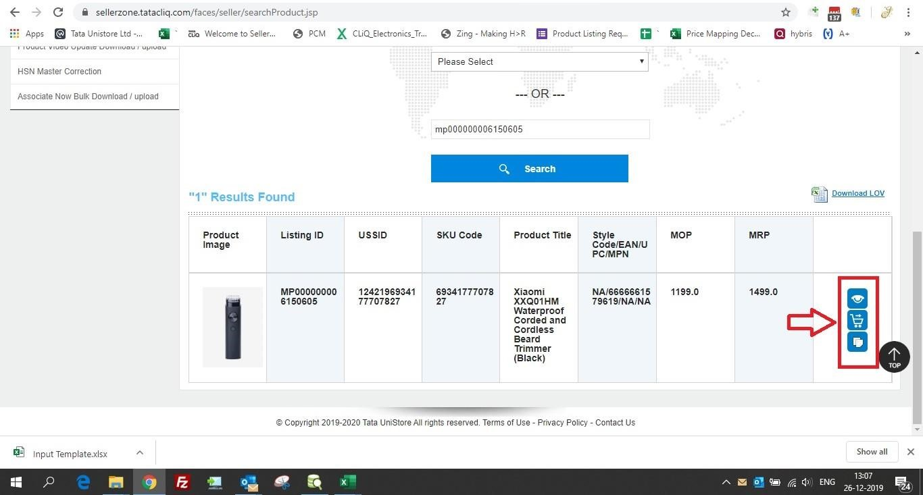

- Fill all the required details SKU code (avoid using special characters, spaces), HSN Code, Start date, End Date (10 years from the current date), Warranty Time Period [Months]= Please always mention number “12”, Warranty Type =Always select “Brand”, Lead time for the SKU-Home Delivery =Please always mention number “1” and weight in Grams.
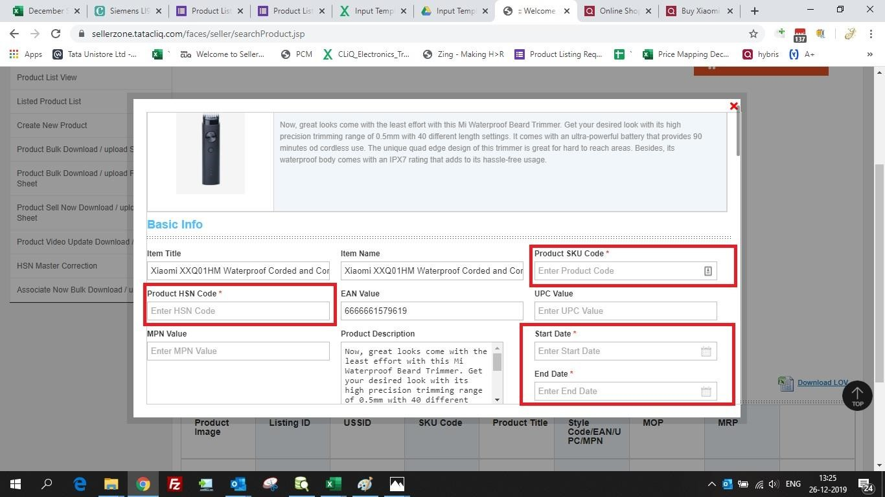
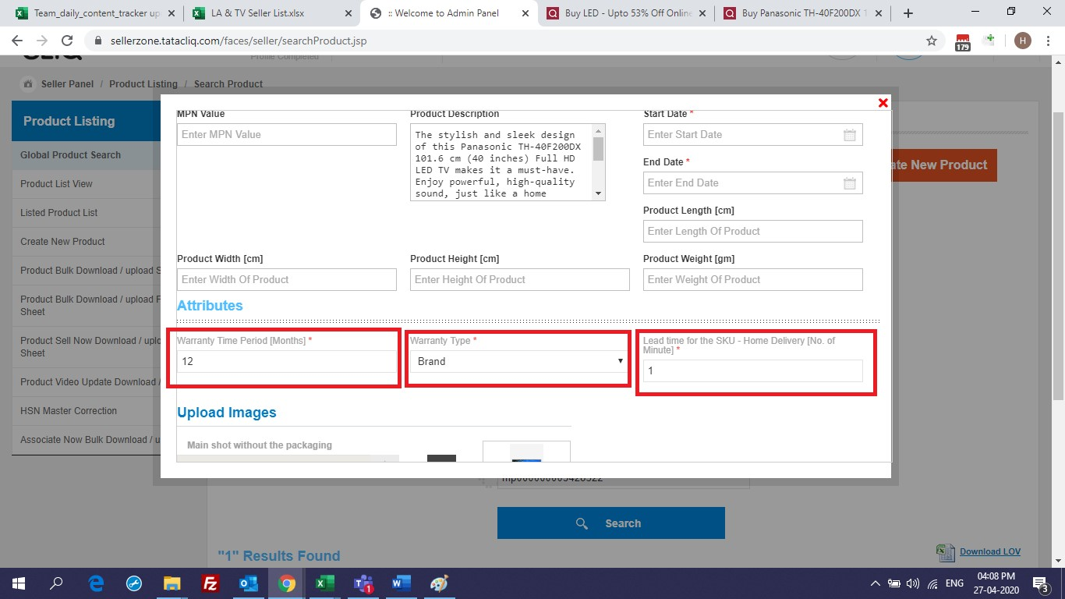

- After filling all the required data, click on the “Sell Product Now” button:
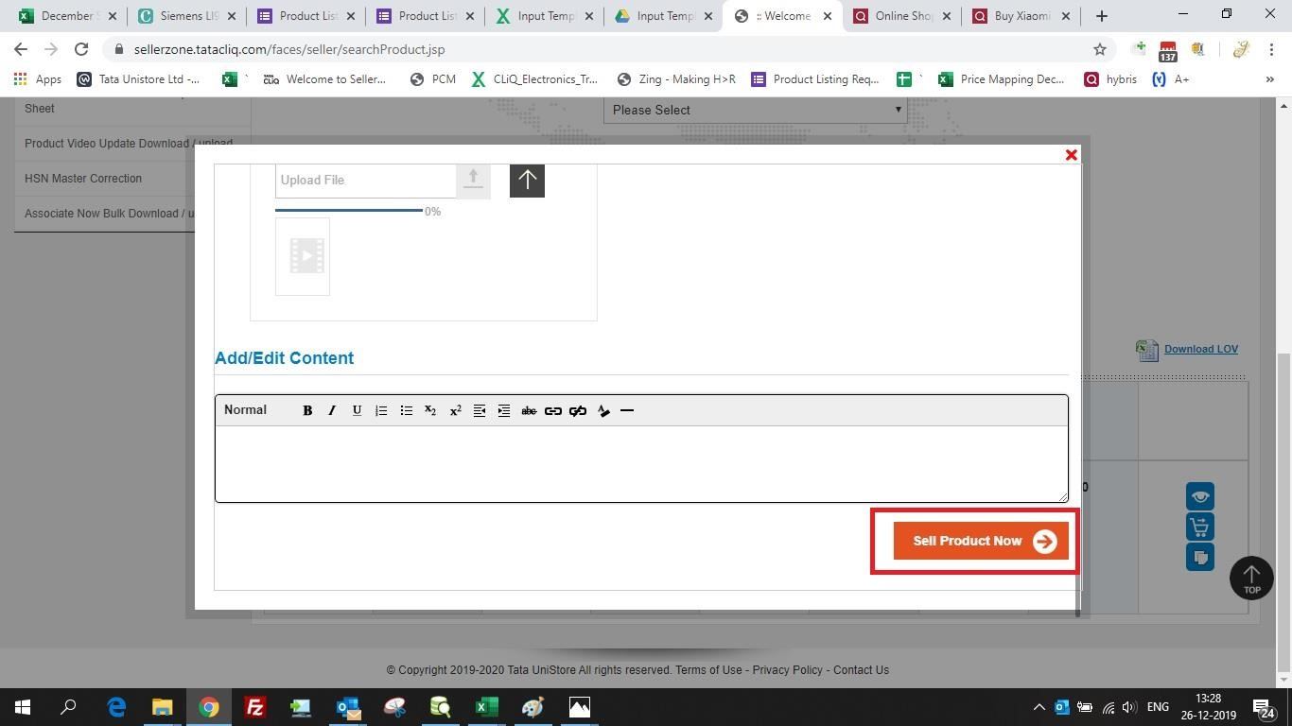

- Once step 7 is completed, following message will pop-up:
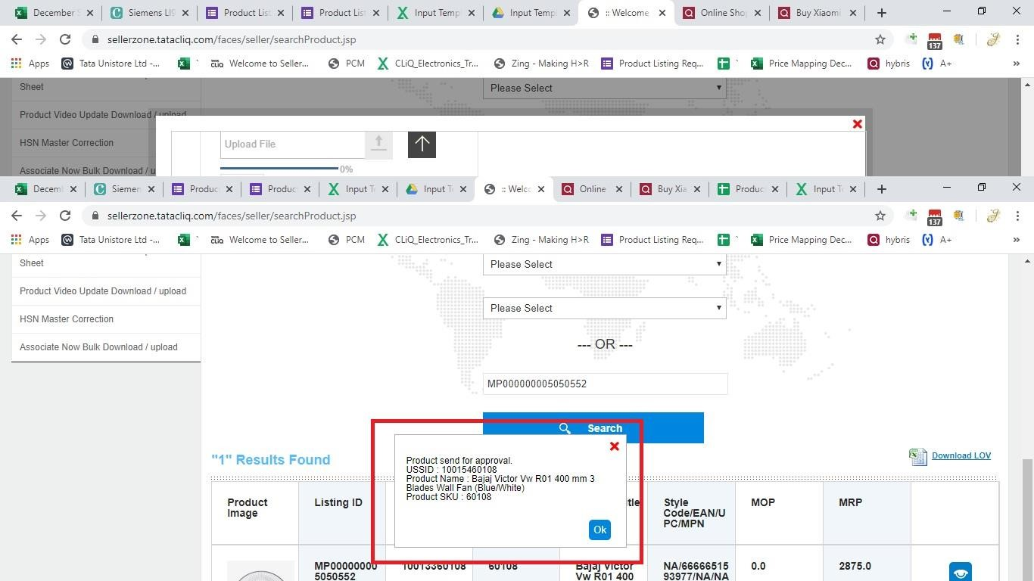

- After completion of Sell now process, Listing ID’s will be visible in Seller Account after 12 hours, if not please reach out to your account manager.

Bulk Sell Now
1.Open the bulk file
2. Fill in the mandatory data – SKUCODE-
HSNCODE-
LISTINGID –
GLOBALIDENTIFIERCODE- EAN (by default),
PRODUCT GLOBAL IDENTIFIER VALUE (EAN Code)- 13digit ean code
STARTDATE-
ENDDATE-
WEIGHT (in grams)-
warrantyTimePeriod- 12 (by default value)
warrantyType- Brand (by default calue)
eadTimeForTheSKUHomeDelivery – 1 (by default value)

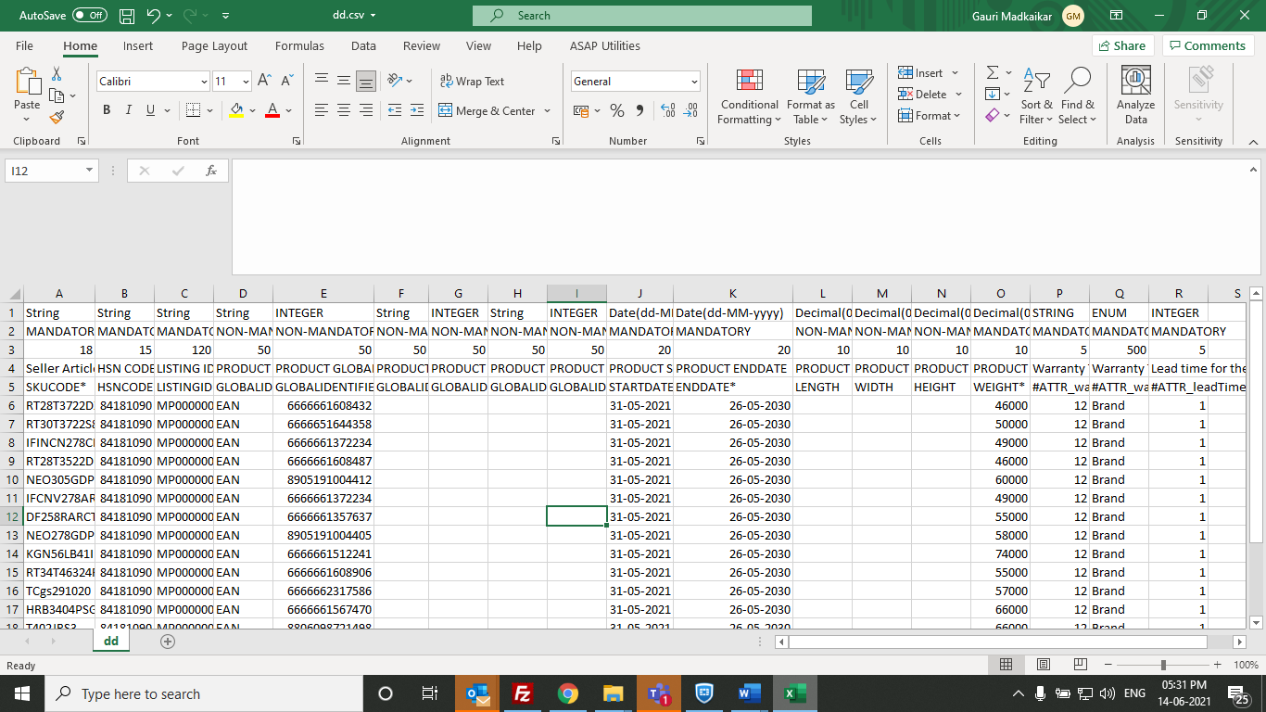

3. Save the file in csv format
4.Login into respective seller account
5.Product Listing> Product Sell Now Download/upload sheet> Select L1 to L4>Upload> System will give summary file check it and close it.

SKU Edit and Re-trigger:
- Edit and Re-trigger feature will be used when details of the existing product should be changed or updated.
- It will be available under master data setup in home page.
- Under master data setup we have option “SKU Edit and re-trigger” on click of these options the edit and Re-trigger journey will start.
- Need to input seller code and click on “Download format” to download the excel sheet.
- Once the excel sheet is downloaded, we need to enter the all the Mandatory fields of the product.
- Once all the necessary fields are filled, we need to save the file in CSV format, and upload the file.
- Once the file to uploaded to the server, it will show the status of the file whether upload is success or failed.
- If the upload of the file is failed, then specific reason will be displayed in the sheet.
- Once the file get uploaded, then the particular products will be sent for approval, once the approval got approved then the product will be listed.
- For approval The clone job takes minimum of 4-5 hours to get approved.

Step 1: Home Page for seller portal: Edit and Re-trigger feature journey will start by clicking on master data setup.
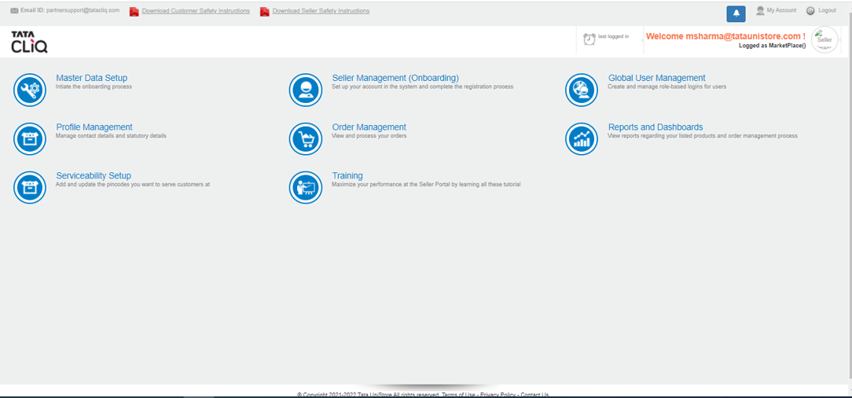

Step 2: Upload Sheet can be found under SKU Edit and Re-trigger- User needs to click on USSID file download button to download the excel sheet.
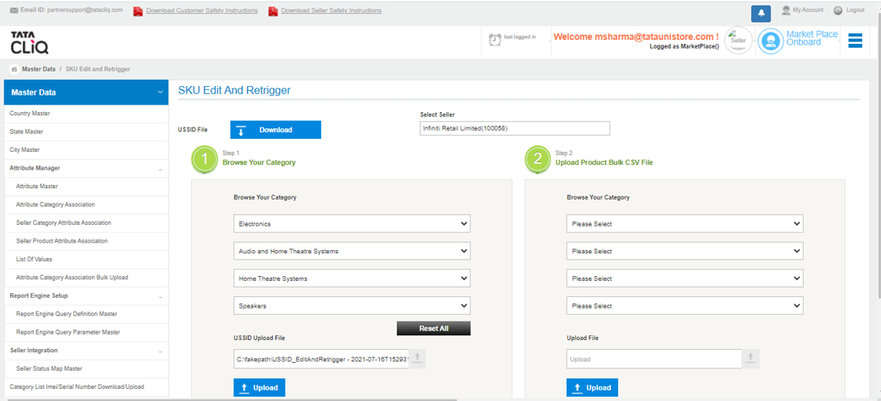

Step 3: Once the Categories are selected and USSID details are entered then click on Upload button to upload the excel sheet.


Step 4: Enter the All the Mandatory fields in the excel sheet.
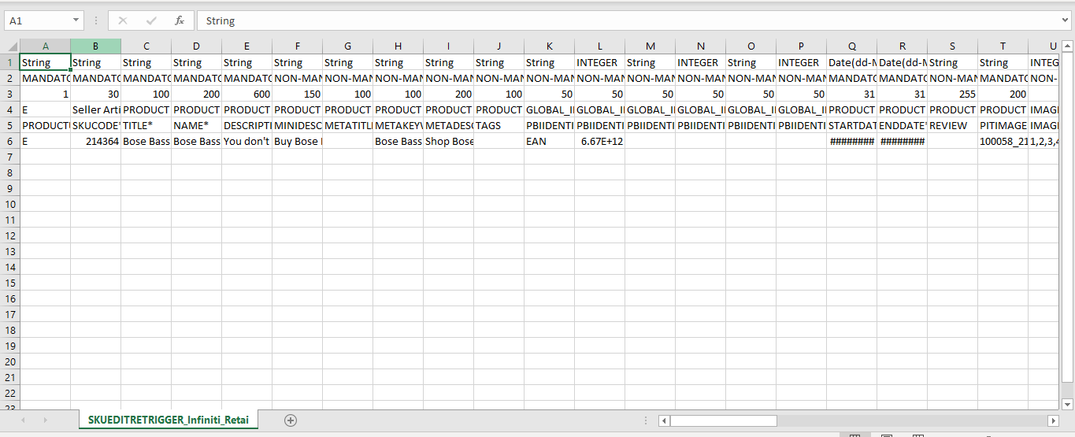

Step 5: Once all the details are entered, then save the file in CSV format and upload.


Step 6: Once the file is uploaded, then it will be sent for approval.

MultiPlatform for enabling single listing on different platforms – MPL, LUX, Pallete

Initially in TataCliq, one product was mapped to only one eCommerce platform i.e., Marketplace / Luxury / Indiluxe. The platform of the product is decided based on brand of the product. Some of the product content varies as per the platform for e.g., image aspect ratio, product catalogue, Sales Hierarchy etc. There was a requirement now to have an ability to upload same product on multiple platforms, which needs changes in multiple systems. Also, there will be a new platform introduced for Beauty products. This section outlines the changes required to enable same product listing on multiple platforms for adding beauty platform
Currently in the system, below three platforms are available,
- Marketplace
- Luxury
- Indiluxe

New platform to be added
- Beauty
- Overview of changes needed

  - Changes in Product onboarding journey
Old Journey
- Currently, platform i.e., Luxindicator of the product is decided in PCM based on brand of the product.
- Brand is marked by business user as Luxury / Marketplace/Indiluxe at the time of brand creation.
- The same Luxindicator is exported to Commerce along with product details. Based on this indicator, Commerce assigns the product to that specific Catalogue.
- Image Aspect ratios are different for Marketplace and Luxury product images
- Current image naming convention followed is: <Seller ID>_<SKUID>_<Priority>.jpeg
Revised Journey
- There will be a new attribute created at USSID level (Platform Name) which will capture the platform where the product is to be listed
- Seller / Content team must upload Platform Name along with Product details while product is created. It will be a multivalued attribute where; product can be assigned to more than one platform.
- Product can belong to either Luxury or IndiLuxe, not both.
- PCM will consume this Luxindicator rather than deriving it based on Brand
- New Image naming format to be used is <Platform>_<Seller ID>_<SKUID>_<Priority>.jpeg
- Beauty platform will allow images in same aspect ratio as that of Luxury & Indiluxe
- Platform naming convention:
  - Marketplace - MP
  - Luxury, Indiluxe, Beauty - LUX
- PCM will maintain product approval status at a platform level so that a product can be published to one platform even if it has some errors for other platform. This will be maintained in ‘Platform Level Approval Status’ attribute

Important points:
- If the product is listed under a particular platform but images are not provided in the format expected for that platform, the product will not be approved for that particular platform.
- Luxury, IndiLuxe & Beauty will expect input images in same aspect ratio. Both these 3 platforms can use one set of images

Scenarios:
Sr No | Scenario | Success/Failure
1 | A product is listed in one of the platforms i.e. Marketplace/Luxury/Indiluxe/Beauty | Success
2 | Product is listed under Luxury & Indiluxe both | Failure. Product can belong to either Luxury or Indiluxe
3 | Product is listed under more than one platform out of Marketplace/Luxury/Beauty | Success
4 | Product is listed in one or more valid platforms with appropriate input images | Success
5 | Product is listed under one or more valid combination of platform, but images are not provided for all the platforms | Product will be approved for a platform with appropriate images & will be rejected for platform without proper images
6 | Product is listed under one or more valid combination of platform, but rich attribute default values are not set for the L4-Platform level combination | Failure
7 | Product is listed under one or more valid combination of platform, rich attribute default values are set for the L4-Platform level combination | Success
8 | Product is listed under one or more valid combination of platform, but the sales hierarchy relevant to those platforms is not set | Failure
9 | Product is listed under one or more valid combination of platform, the sales hierarchy relevant to those platforms is set | Success
10 | Primary Seller lists a product in one Platform, Uses Edit & Retrigger functionality from SP to list the same product under another platform. | Success

Changes to Rich attribute management

Currently Rich attributes are maintained at L4, Seller-L4, Seller-L4-Brand & USSID level. With the change of allowing product to be tagged to multiple platforms, rich attribute management must be done at platform level for all the combinations.

Following are the changes done in Rich attribute management:
- Business user can update rich attributes at the below levels.

Sr. No. | Functionality | File name
1 | USSID | <seller>-richattributeussid_<timestamp>.csv
2 | Listing ID | <seller>-richattributeussid_<timestamp>.csv
3 | Seller – L4 - platform | <seller>-richattributecategory_<timestamp>.csv
4 | Seller – L4 – Brand - platform | <seller>-richattributecategory_<timestamp>.csv
5 | L4 - platform | <seller>-richattributecategory_<timestamp>.csv
- Platform is mandatory in Seller – L4 – Brand - platform, Seller – L4 – platform, L4 –platform rich attribute update.
- If brand is given in the file <seller>-richattributecategory_<timestamp>.csv, then it will be considered as seller – L4 – Brand-platform functionality.
- If brand is not provided in the file '<seller>-richattributecategory_<timestamp>.csv', then PCM will consider as seller – L4 - platform functionality.
- If brand and seller are not provided in the file '<seller>-richattributecategory_<timestamp>.csv', then PCM will consider as L4 - platform functionality.
- For updating rich attributes, more than one attribute can be provided in single file. Rich attributes for more than one seller can be updated.
- Business user can set the rich attribute values at Seller – L4 – Brand - platform, Seller – L4 – platform, L4 – platform level even though no products are created under that seller – L4 combination.
- User can update the rich attributes based on the three flags.
  - If user needs to update the default values and the values needs to be reflected to USSIDs, then business user should give the flag as 1.
If user need to update only the default values without updating the value at USSIDs level, then business user should give the flag as 2.
  - If brand is given in seller-richattributecategory-20171124055100.csv and override flag as 3, then we will export Seller- L4 - platform entries that were created under the given brand.
  - If brand is given as null in provided seller-richattributecategory-20171124055100.csv and override flag is 3, then PCM will export all the entries that were created with the given seller – L4 - platform combination as a separate report.

- Templates for the input files :
  - Seller – L4 - platform and Seller – L4 – Brand -platform
    - Example: Business user need to update one rich attribute (Payment Mode), then the file format should follow the below given below template.
    - File Name : <seller>-richattributecategory_<timestamp>.csv
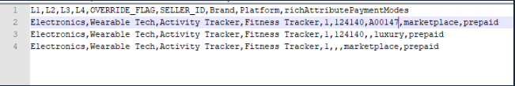
Note :
    - In this case, Brand will be optional attribute.
    - The attribute set for update should be same for all the sellers, or else file will be rejected.

  - 2. USSID and ListingID
    - Example : User need to update two rich attributes (rAttIsFragile and rAttGiftWrappable) for ussid , then the file format should follow the below template.
    - File Name : <seller>-richattributeussid_<timestamp>.csv
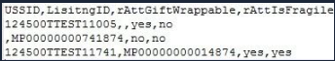
Note:
    - If USSID is given, then PCM will update the values only for that USSID.
    - If listing ID is provided, then PCM will update the rich attribute values for the USSIDs mapped to that listing ID.
    - If USSID and listing ID is given, then USSID will take precedence and PCM will update rich attribute values for USSIDs by ignoring the listing ID.
    - The rich attribute values will be maintained at USSID platform level. Currently, the rich attribute update utility does not have platform column. In future, USSID level update will have an additional column for Platform Name

  - Changes to “Sell Now” Process

Currently during “Sell Now” process, Seller searches for a Product and initiates Sell Now process for the same, this associates new USSID with the existing listing ID.

With the multiplatform changes, Seller should have an ability to select a platform (Marketplace/Luxury/Indiluxe) during Sell Now via UI or Bulk. This information will be consumed by PCM and accordingly product information (images, rich attributes etc.) is processed

In Phase 1, Sell now will be enabled for same platform i.e. Secondary seller can do Sell Now under same platforms for which Primary Seller would have listed the product under.

Important points for next Phase:
- If Primary Seller has listed a product in any one particular platform, secondary sellers can do “Sell Now” on the same platform or additional valid platforms
- Secondary seller can not list the product on IndiLuxe if primary product is listed under Luxury. The USSID should get rejected
- Secondary seller cannot list the product on Luxury if primary product is listed under IndiLuxe. The USSID should get rejected

Sr No | Scenario | Success/Failure
1 | A product is listed in one of the platforms by Primary seller, secondary seller does “Sell Now” under same platform | Success
2 | A product is listed under Luxury by Primary seller, secondary seller does “Sell Now” under different platform | Failure
3 | A product is listed in one of the platforms by Primary seller, secondary seller does “Sell Now” under different valid platform and provides valid images for new platform | Success
4 | A product is listed in one of the platforms by Primary seller, secondary seller does “Sell Now” under different valid platform, but does not provide valid images for new platform | Failure
5 | A product is listed in one of the platforms by Primary seller, secondary seller does “Sell Now” under different valid platform, provides valid images for new platform & default values for Seller-L4-Platform level rich attributes are set | Success
6 | A product is listed in one of the platforms by Primary seller, secondary seller does “Sell Now” under different valid platform, provides valid images for new platform & default values for Seller-L4-Platform level rich attributes are NOT set | Success. Seller-L4 level rich attributes are inherited for Seller-L4-Plaform level.
7
8
9

  - PCM Hybris Cockpit UI changes

- There is Platform level product status displayed in cockpit to understand if a product is approved/rejected for a particular platform
- USSID information tab will be read-only.
- Separate perspective developed to view the USSID level rich attribute information.

